

AP® Physics C
1978 Free Response Questions

The materials included in these files are intended for use by AP teachers for course and exam preparation in the classroom; permission for any other use must be sought from the Advanced Placement Program®. Teachers may reproduce them, in whole or in part, in limited quantities, for face-to-face teaching purposes but may not mass distribute the materials, electronically or otherwise. These materials and any copies made of them may not be resold, and the copyright notices must be retained as they appear here. This permission does not apply to any third-party copyrights contained herein.

These materials were produced by Educational Testing Service® (ETS®), which develops and administers the examinations of the Advanced Placement
Program for the College Board. The College Board and Educational Testing Service (ETS) are dedicated to the principle of equal opportunity, and their
programs, services, and employment policies are guided by that principle.

The College Board is a national nonprofit membership association dedicated to preparing, inspiring, and connecting students to college and opportunity.
Founded in 1900, the association is composed of more than 4,200 schools, colleges, universities, and other educational organizations. Each year, the
College Board serves over three million students and their parents, 22,000 high schools, and 3,500 colleges, through major programs and services in
college admission, guidance, assessment, financial aid, enrollment, and teaching and learning. Among its best-known programs are the SAT®, the
PSAT/NMSQT®, and the Advanced Placement Program® (AP®). The College Board is committed to the principles of equity and
excellence, and that commitment is embodied in all of its programs, services, activities, and concerns.

APIEL is a trademark owned by the College Entrance Examination Board. PSAT/NMSQT is a registered trademark jointly owned by the College Entrance Examination Board and the National Merit Scholarship Corporation. Educational Testing Service and ETS are registered trademarks of Educational Testing Service.
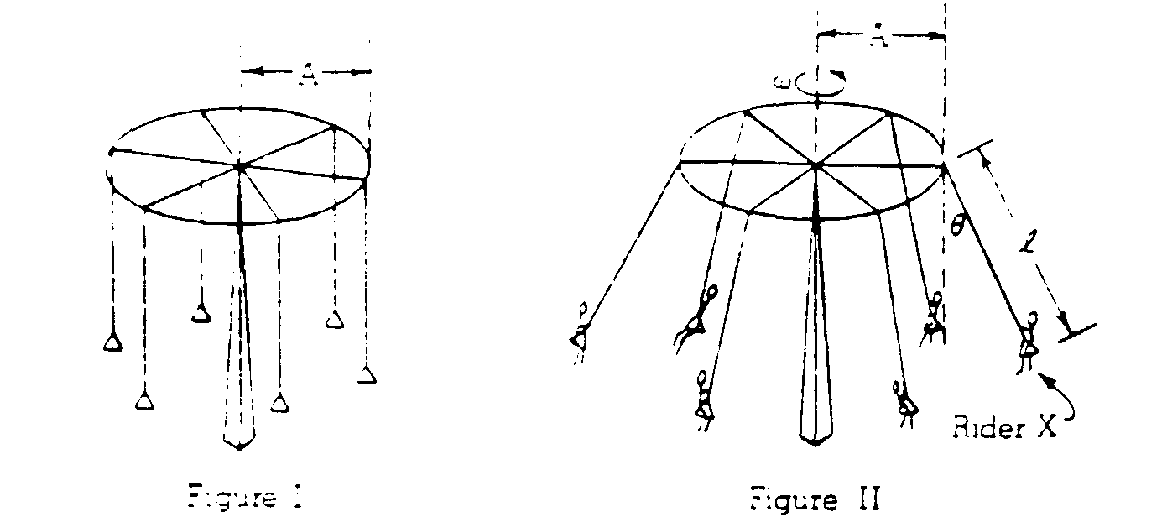
1978M1. An amusement park ride consists of a ring of radius A from which hang ropes of length l with seats for the riders as shown in Figure I. When the ring is rotating at a constant angular velocity ω each rope forms a constant angle θ with the vertical as shown in Figure II. Let the mass of each rider be m and neglect friction, air resistance, and the mass of the ring, ropes, and seats.
a. In the space below, draw and label all the forces acting on rider X (represented by the point below) under the constant rotating condition of Figure II. Clearlv define any symbols You introduce.


b. Derive an expression for ω in terms of A, l, θ and the acceleration of gravity g.
c. Determine the minimum work that the motor that powers the ride would have to perform to bring the system from rest to the constant rotating condition of Figure II. Express your answer in terms of m, g, l, θ, and the speed v of each rider.

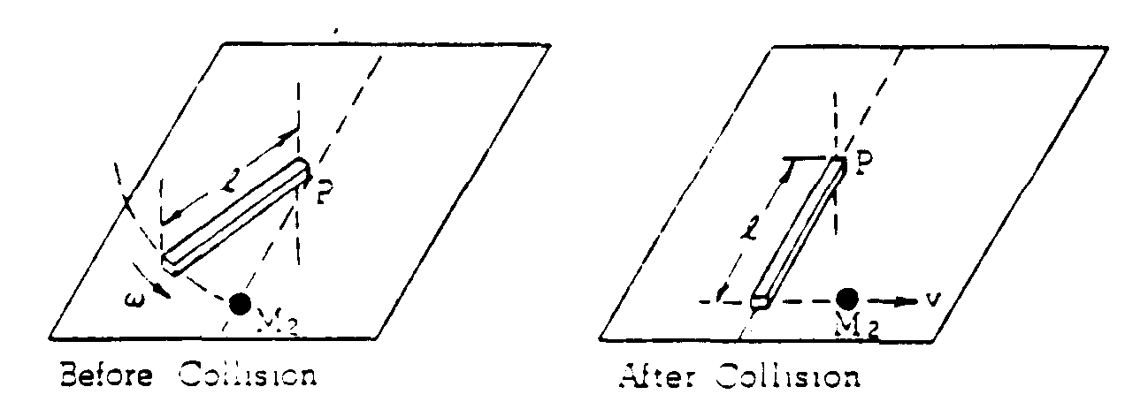
1978M2. A system consists of a mass M₂ and a uniform rod of mass M₁ and length l. The rod is initially rotating with an angular speed ω on a horizontal frictionless table about a vertical axis fixed at one end through point P. The moment of inertia of the rod about P is Ml²/3. The rod strikes the stationary mass M₂. As a result of this collision, the rod is stopped and the mass M₂ moves away with speed v.
a. Using angular momentum conservation determine the speed v in terms of M₁, M₂, l, and ω.
b. Determine the linear momentum of this system just before the collision in terms of M₁, l, and ω.
c. Determine the linear momentum of this system just after the collision in terms of M₁ l, and ω.
d. What is responsible for the change in the linear momentum of this system during the collision?
e. Why is the angular momentum of this system about point P conserved during the collision?

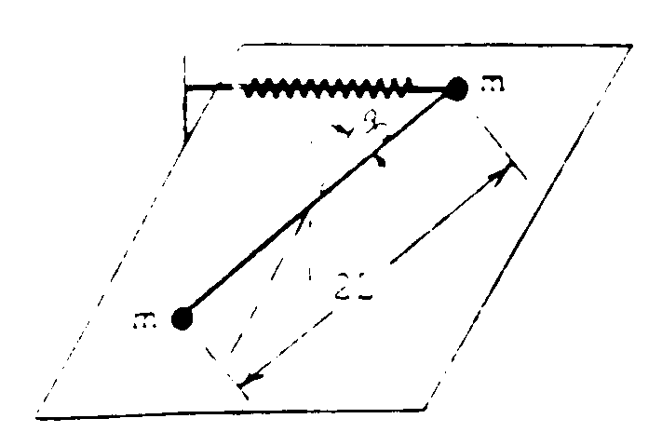
1978M3. A stick of length 2L and negligible mass has a point mass m affixed to each end. The stick is arranged so that it pivots in a horizontal plane about a frictionless vertical axis through its center. A spring of force constant k is connected to one of the masses as shown above. The system is in equilibrium when the spring and stick are perpendicular. The stick is displaced through a small angle θ_{o} as shown and then released from rest at t = 0 .
a. Determine the restoring torque when the stick is displaced from equilibrium through the small angle θ_{o}.
b. Determine the magnitude of the angular acceleration of the stick just after it has been released.
c. Write the differential equation whose solution gives the behavior of the system after it has been released.
d. Write the expression for the angular displacement θ of the stick as a function of time t after it has been released from rest.

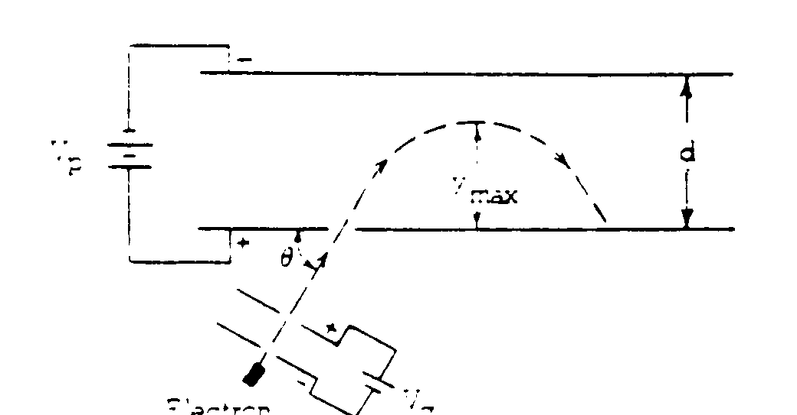
1978E1. Electrons are accelerated from rest in an electron gun between two plates that have a voltage V_{g} across them. The electrons then move into the region between two other parallel plates of separation d that have voltage V_{p} across them. The electrons are projected into this region at an angle θ to the plates as shown above. Assume that the entire apparatus is in vacuum and that V_{p} > V_{g}. Display all results in terms that include d, V_{g}, V_{p}, θ, e (the magnitude of the electron charge), and m_{o} (the electron mass).
a. Develop an equation for the speed v_{e} with which the electrons leave the electron gun.
b. Develop an equation for the maximum distance y_{max} that the electrons travel above the lower plate.

Suppose that a magnetic field directed into the plane or the paper is introduced in the region between the upper plates
c. How will the speed with which the electrons strike the lower plate be affected? Explain.
d. Sketch on the diagram a trajectory that an electron might follow with the magnetic field present. Account qualitatively for the difference between the new and old trajectory.

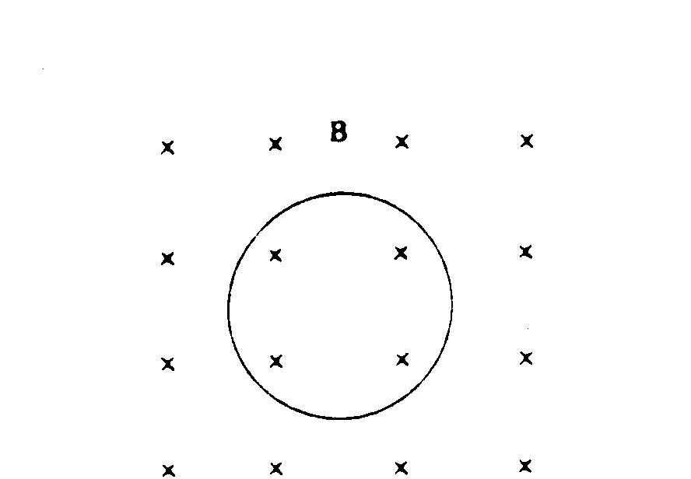
1978E2. A circular loop of wire of area A and electrical resistance R is placed in a spatially uniform magnetic field B directed into the page and perpendicular to the plane of the loop as shown above. The magnetic field is gradually reduced from an initial value of B_{o}, in such a way that the magnetic field strength as a function of time is B(t) = B_{o}e^{-αt}.
a. Indicate on the diagram the direction of the induced current. Applying the fundamental relation for electromagnetic induction, explain your choice.
b. Do the electromagnetic forces on this current tend to make the loop expand or contract? Explain.
c. Determine an expression, in terms of B_{o}, A, and R, that describes the total quantity of charge that flows past a point in the loop during the time the magnetic field is reduced from B_{o} to zero.
d. Determine an expression for the amount of energy dissipated as heat in the loop, in terms of B_{o}, A, R, and α, during the time the magnetic field is reduced from B_{o} to zero.

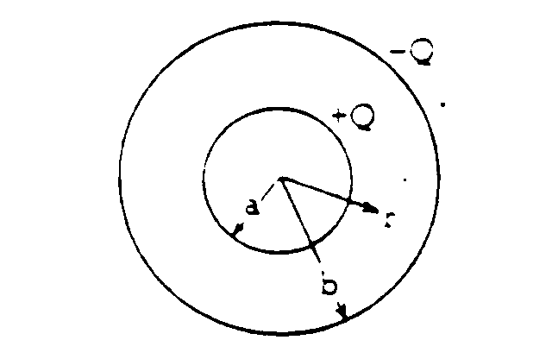
1978E3. A capacitor is composed of two concentric spherical shells of radii a and b, respectively, that have equal and opposite charges as shown above. Just outside the surface of the inner shell, the electric field is directed radially outward and has magnitude E_{o}.
a. With the use of Gauss's law, express the charge +Q on the inner shell as a function of E_{o} and a.
b. Write an expression for the electric field strength E between the shells as a function of E_{o}, a, and r.
c. What is the potential difference V between the shells as a function of E_{o}, a, and b?
d. Express the energy U stored in this capacitor as a function of E_{o}, a, and b.
e. Determine the value of a that should be chosen in order to maximize U, if E_{o} and b are fixed.

